SIMATS ENGINEERING
ASSESSMENT TOOL 2: Concept Mapping
COURSE NAME: COMPUTER VISION
COURSE CODE:DSA0205

Code of Conduct
I V M SAI BHARGAV certify that this submission is my original work and that I have adhered to the guidelines specified for this assessment. I understand that any violation of academic integrity rules will result in disciplinary action.
Signature of the student: V M SAI BHARGAV

Topic 6: Digital Image Formation Workflow
Construct a concept map that identifies the complete workflow of digital image formation, clearly linking sensing, sampling, and quantization stages with their impact on image quality, integrating relevant literature insights, and presenting the relationships in a structured and visually coherent manner.
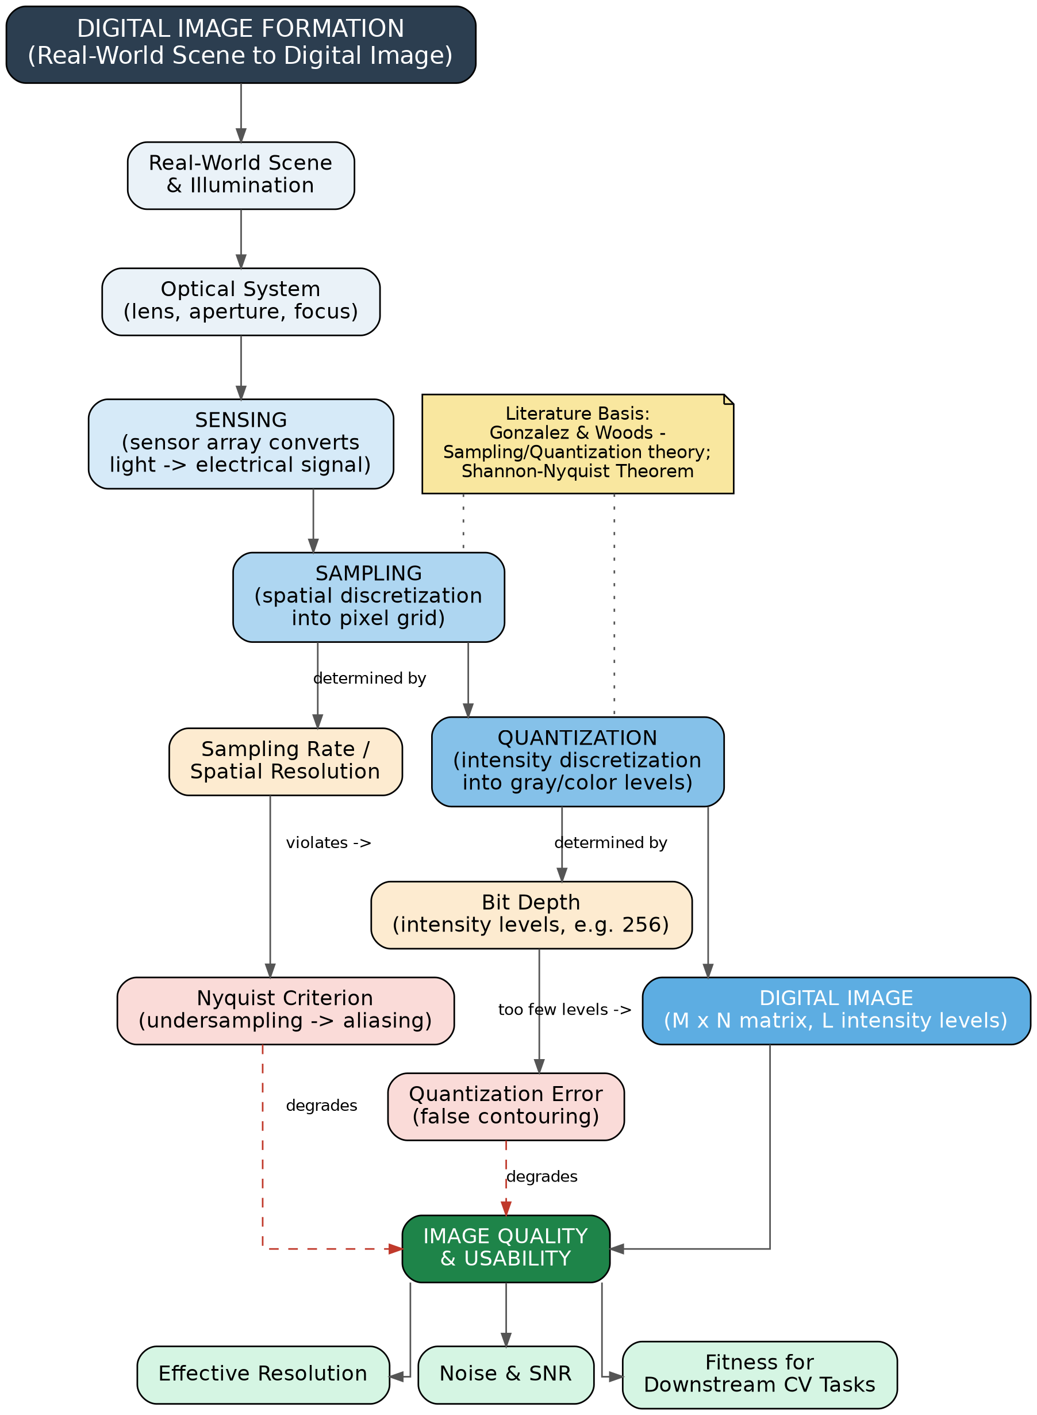
Figure 1: Concept map of the digital image formation workflow, from scene capture to digital image and quality outcomes.

Concept Identification
The map identifies every stage of the pipeline named in literature: the real-world scene and illumination, the optical system, the sensing stage (photon-to-electrical conversion), spatial sampling into a pixel grid, and intensity quantization into discrete gray/colour levels, culminating in the final digital image (an M × N matrix with L intensity levels).
Directed edges show that sampling rate governs spatial resolution and that undersampling below the Nyquist rate causes aliasing; similarly, bit depth governs the number of intensity levels and too few levels produce false contouring (banding). Both aliasing and quantization error are linked (dashed, red) to the final Image Quality node, showing how earlier-stage decisions propagate downstream.
The sampling branch draws on the Shannon–Nyquist sampling theorem, and the overall pipeline structure follows the standard image-formation model described in Gonzalez & Woods' Digital Image Processing, which frames image formation as sequential sensing, sampling and quantization stages.
The map flows top-to-bottom in strict pipeline order, with a colour gradient (light blue → dark blue → green) marking progression from raw signal to final quality assessment, so the hierarchy is readable at a glance.

Topic 7: Levels of Computer Vision
Develop a concept map that identifies different levels of Computer Vision, establishes relationships between low-level processing, mid-level analysis, and high-level interpretation, integrates literature-based examples, and ensures clear hierarchical organization.
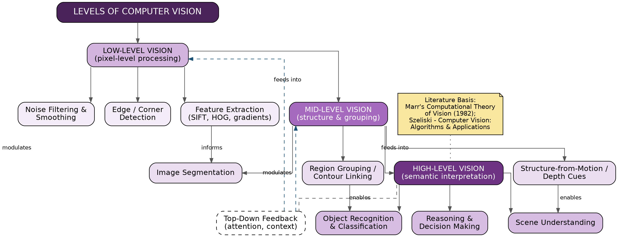
Figure 2: Concept map of the three levels of Computer Vision and their interconnections.

Concept Identification
The map identifies the three canonical levels — low-level vision (noise filtering, edge/corner detection, feature extraction such as SIFT/HOG), mid-level vision (segmentation, region grouping, structure-from-motion), and high-level vision (object recognition, scene understanding, reasoning) — with representative techniques nested under each.
Solid arrows show the forward, bottom-up flow of information (low → mid → high), while specific cross-links (e.g., feature extraction informing segmentation, region grouping enabling object recognition) show how individual sub-concepts feed one another rather than treating each level as a black box. A dashed top-down feedback loop from high-level reasoning back into mid- and low-level stages captures attention/context effects documented in the literature.
The three-level structure follows Marr's computational theory of vision, which separates early (low-level), intermediate (mid-level) and interpretive (high-level) stages of visual processing, and is further supported by the level-based treatment of Computer Vision tasks in Szeliski's Computer Vision: Algorithms and Applications.
A single vertical hierarchy with three shaded tiers (light to dark purple) keeps the levels visually distinct, while the feedback loop is rendered as a dashed line so it does not interfere with the primary bottom-up reading order.

Topic 9: Image Sensing Mechanisms
Design a concept map that identifies the role of image sensing mechanisms, clearly establishing relationships between sensor characteristics, noise generation, and acquisition quality, integrating literature perspectives, and ensuring logical flow.
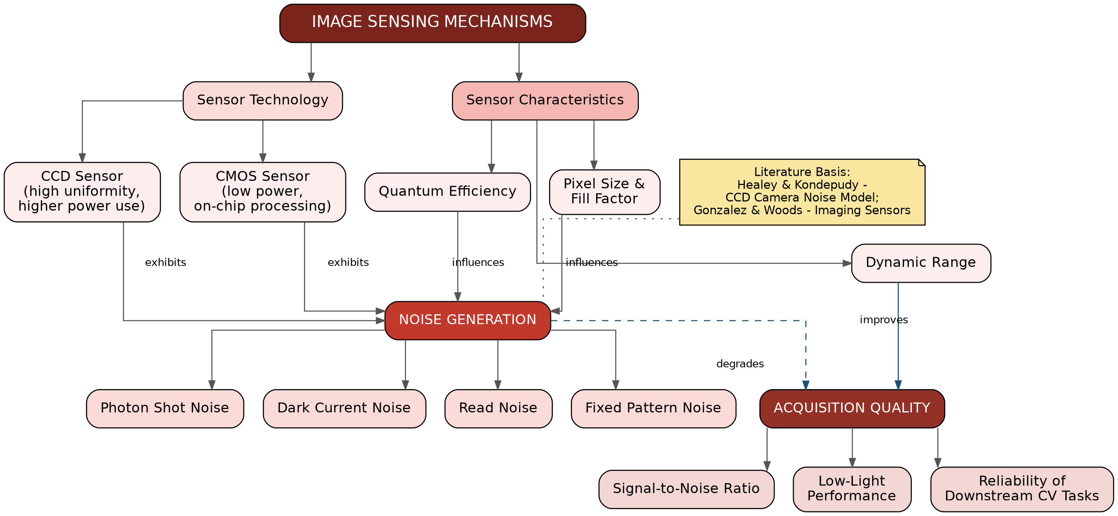
Figure 3: Concept map linking sensor technology and characteristics to noise sources and final acquisition quality.

Concept Identification
The map covers sensor technology (CCD and CMOS), core sensor characteristics (quantum efficiency, dynamic range, pixel size/fill factor), the major noise sources present in imaging sensors (photon shot noise, dark current noise, read noise, fixed pattern noise), and the resulting acquisition-quality outcomes (signal-to-noise ratio, low-light performance, and reliability for downstream Computer Vision tasks).
Edges show that both sensor type and characteristics such as quantum efficiency and pixel size directly influence the degree of noise generation, that noise (dashed, red) degrades acquisition quality, while a larger dynamic range improves it. This establishes a clear causal chain from physical sensor design to real-world image usability.
The noise taxonomy follows established CCD/CMOS sensor noise modelling work such as Healey and Kondepudy's camera noise model, and the sensing-stage description is consistent with the imaging-sensor treatment in Gonzalez & Woods' Digital Image Processing.
A warm red colour scale (light to dark) traces the causal path from sensor technology through noise to final quality, keeping the four-stage logical flow (technology → characteristics → noise → quality) visually unambiguous.

